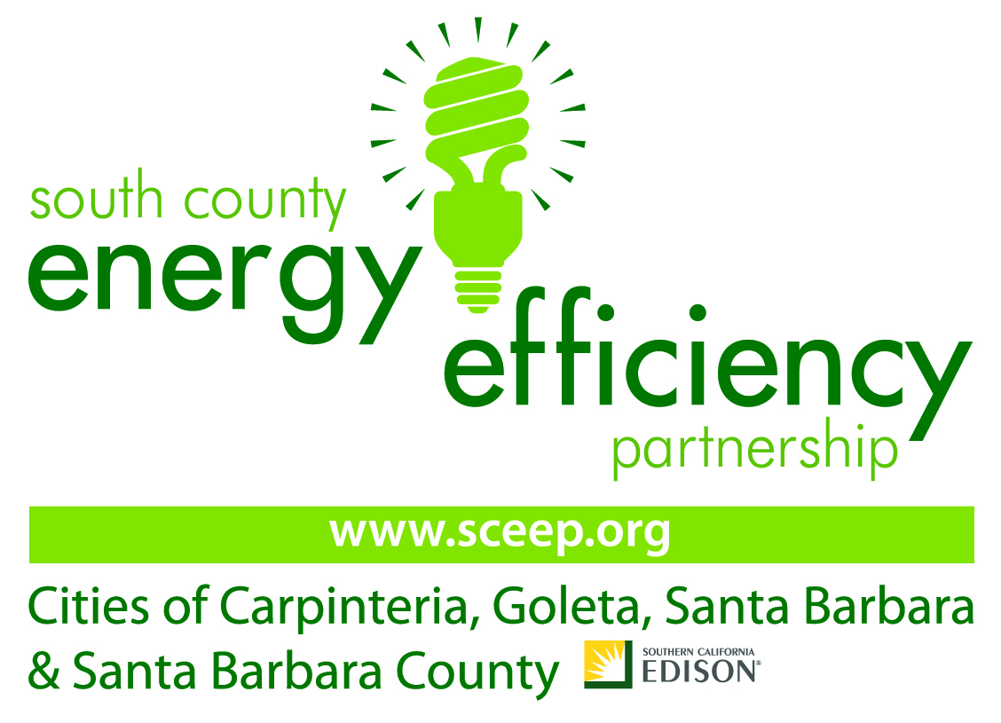

For Immediate Release Press Contacts: Chris Davis/Marjorie Wass 805/687-3322

Community Invited to Learn How to Use Solar Power in the Home, Saving Money and Energy

Presentation includes information on New Tax incentives

Goleta, CA, March 31, 2009 –Local homeowners are invited to attend a special presentation on solar energy in their homes. The Homeowner Solar Information Session will take place on Wednesday, April 8, from 6:30 to 8:00 p.m. at Southern California Edison’s Service Center in Goleta, 103 David Love Place.

This presentation is provided by Southern California Edison through its California Solar Initiative (CSI) and sponsored by the South County Energy Efficiency Partnership -- local government agencies in partnership with Southern California Edison to help our community save energy, money and the environment.

The Homeowner Solar Information Session is a 90-minute, non-technical; easy to understand homeowner information session that shows homeowners how they can benefit from having a solar energy system installed on their homes. Following the presentation will be a Q&A session to provide homeowners with all the information they need.

“There are a number of important ways households will save money, “explained Javier Burgos, Project Manager for the California Solar Initiative for Southern California Edison. “In addition to the annual energy cost savings, there is a $2.20-per-Watt incentive available through the California Solar Initiative, and a 30% federal tax credit.”

Savings breakdown:
- Very substantial savings on monthly energy bills (depending upon house size and energy usage)
- An average of $8,500 one-time CSI incentive (for a 4-kW system at $2.20 per Watt)
- An additional 30% federal tax credit on the net cost of the installation

This is a free event but space is limited. Light beverages and snacks will be provided. To register online, please go to http://www.sce.com/b-rs/csi/Training/Residential.htm or call (866) 970-9221. For more information, please go to www.sceep.org.

Visit SCEEP.org for more information and to learn about how you can save energy, save money, and help protect the environment.
This program is funded by California utility ratepayers and administered by Southern California Edison under the auspices of the California Public Utilities Commission.
##

