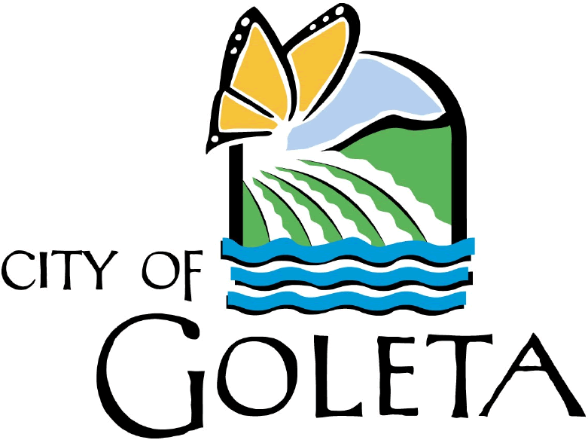

Volunteer Program
Acknowledgement of Workers’ Compensation

I hereby acknowledge that as a volunteer for the City of Goleta I am not an employee of the City of Goleta, but that I am covered under the City's Workers' Compensation plan since the City has adopted a resolution extending Workers' Compensation coverage to certain volunteers in specified categories pursuant to Labor Code Section 3363.5.

As a volunteer who is covered under the City of Goleta’s Workers' Compensation plan, I expressly agree and acknowledge that Workers' Compensation is my exclusive remedy for any injury suffered while performing said volunteer duties, and that I cannot and will not seek to bring any other claim or actions of any type whatsoever against the City of Goleta, its employees, officers, agencies, other volunteers and officials.

Furthermore, I agree that I should I become injured while performing my duties as a volunteer for the City of Goleta, I will immediately inform my supervisor.

Date:
Signature:
Print Name:
Parent or Guardian Signature (if minor):

Witness:

